Name of Student: Husam Ali Abdalla Nour | PRN:25070122086
Semester: III | Year : AY 2026-27
Subject: Programming with Java
ASSIGNMENT No : 15
TITLE : Exception Handling using Finally, Throw, and Throws
Problem Statement
Write a Java program to demonstrate exception handling using finally, throw, and throws.
Learning Objectives
To implement finally, throw, and throws for effective exception management.

Programme
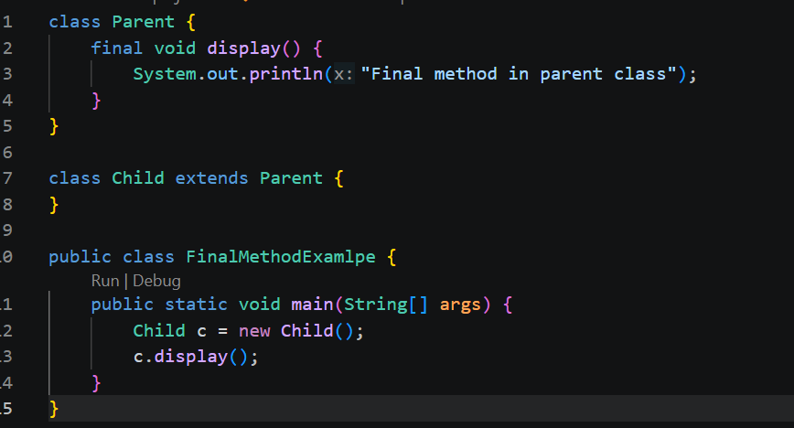

Output
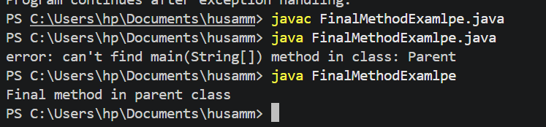
Practice questions
1. Create a Login program that throws an exception for invalid password and uses finally block.
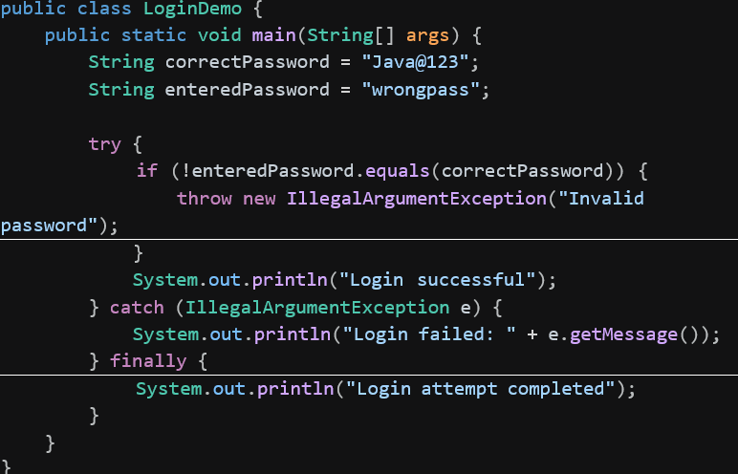
Out put
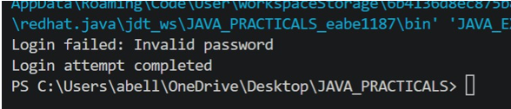

2. Create an ATM PIN Verification program that throws an exception for an invalid PIN entered by the user and uses a finally block to display a message indicating that the verification process has completed.
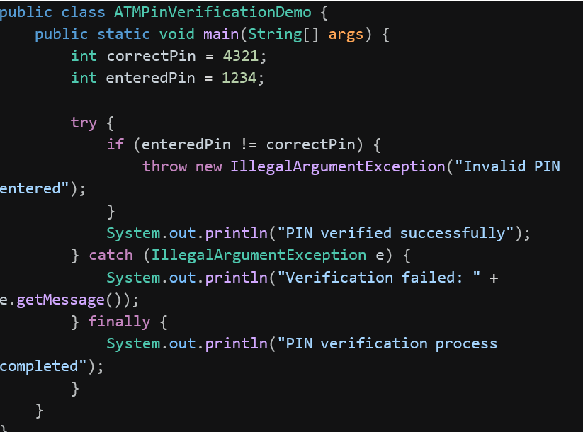
Output
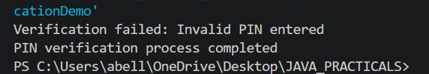
Conclusion
throw and throws give a program precise control over when and how exceptions are raised and propagated, while finally ensures important cleanup or completion logic always runs, whether an exception occurs or not. Together they make exception handling more predictable and reliable, which is essential for critical operations like login checks and ATM transactions.

